FPC 10 CH. 5.2/5.5 (Day 1) Assignment Name:________________
Domain and Range Worksheet
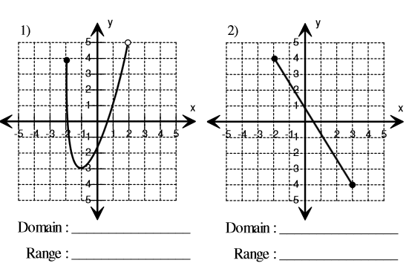
Part A – Use interval Notation to describe the domain and range of the following relations
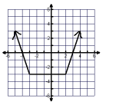
3)

Domain:_______________________

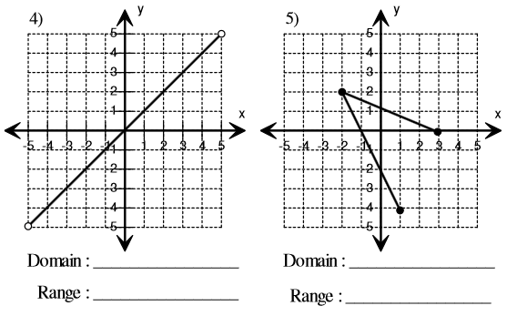
Range: ________________________
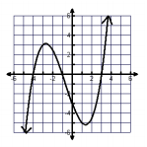
6)

Domain:_________________________

Range:____________________________

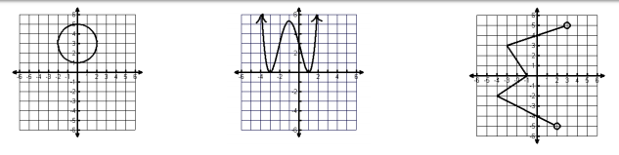
7) 8) 9)

Domain:_________________________ Domain:_________________________ Domain:_________________________

Range:__________________________ Range:_________________________ Range:__________________________

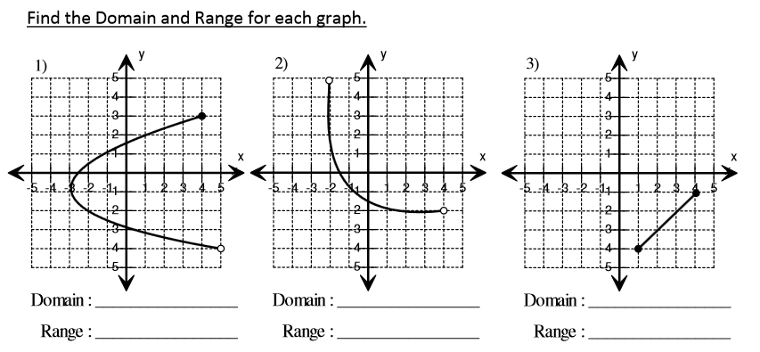
Part B – Use Set Notation or as a list if appropriate to describe the domain and range of the following relations

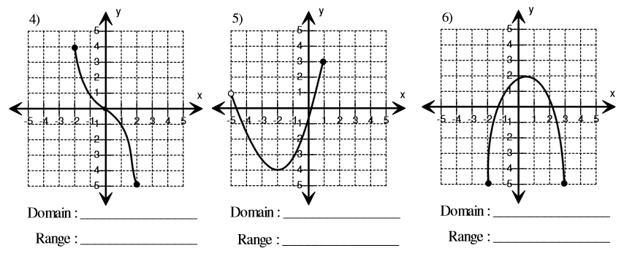

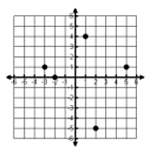
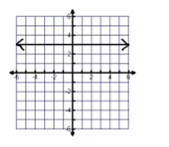
7) 8) 9)

Domain:_________________________ Domain:_________________________ Domain:_________________________

Range:__________________________ Range:_________________________ Range:__________________________

