**3.1 Quadratic Functions in Vertex Form (Day 1/2 Notes)**

Concept #1: To determine the coordinates of the vertex, the domain and range, the axis of symmetry, the x and y intercepts and the direction of opening of the graph of f(x)=a(x – p)2 + q without the use of technology.

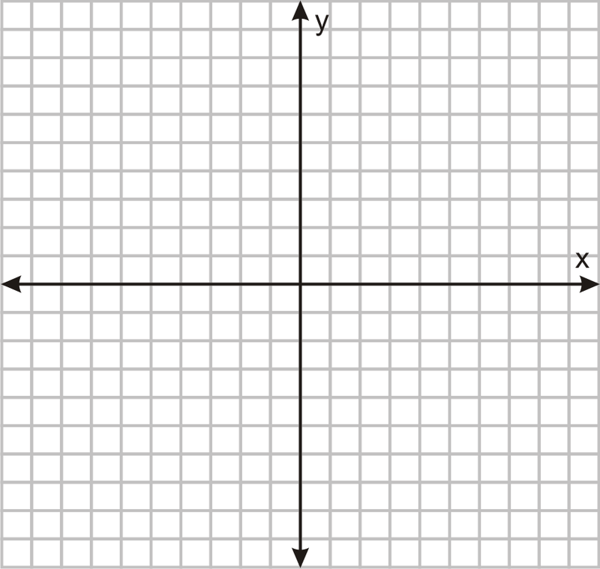EX #1: Using a table of values, sketch y = x2

**REVIEW:**

* A **QUADRATIC FUNCTION** is a function of degree two: y = x2, y = 2x2 – 5x + 1, y = 2(x – 3)2 – 3, y = (x + 1)2
* The graph of a quadratic function is in the shape of a _________________
* A quadratic function is written in STANDARD FORM when it is written in the form _____________________ and it is written in VERTEX FORM when it is in the form ______________________
* The _________ of a parabola is the lowest point in a parabola that opens upwards or the highest point of a parabola that opens downwards.
* If the parabola opens upwards then there is a __________________ value. If the parabola opens down there is a _________________ value. The _________ coordinate of the vertex defines the max or min value.
* The __________________________________ is a line through the vertex that divides the graph of the quadratic function into two congruent halves. The ________________ of the vertex defines the equation of the axis of symmetry.

**EX #2:** State the vertex, the max or min value and the equation of the axis of symmetry for the following:

A B

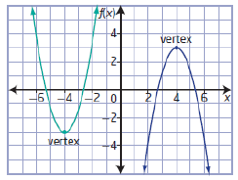

***A. Compare the graphs of f(x)= x2 and f(x)= ax2***

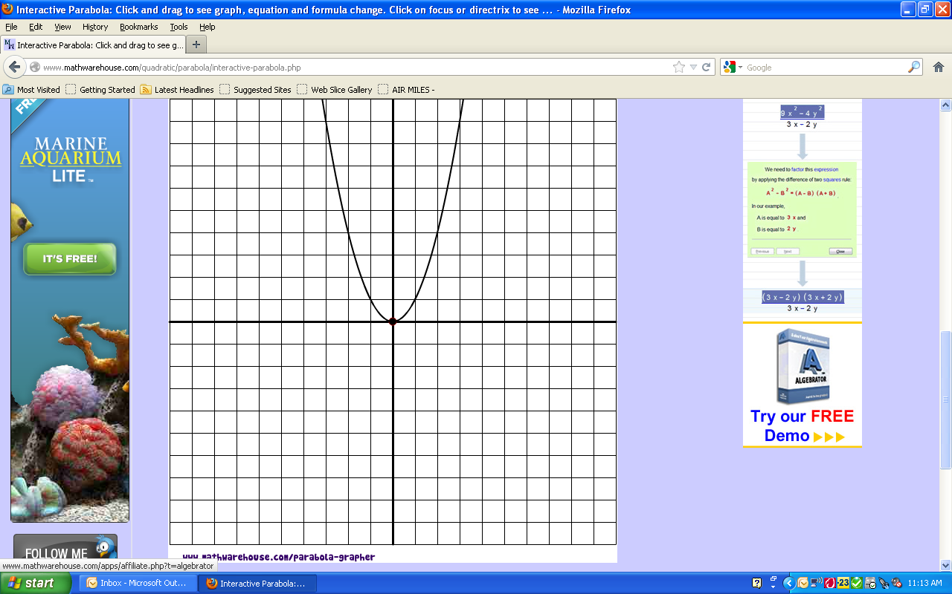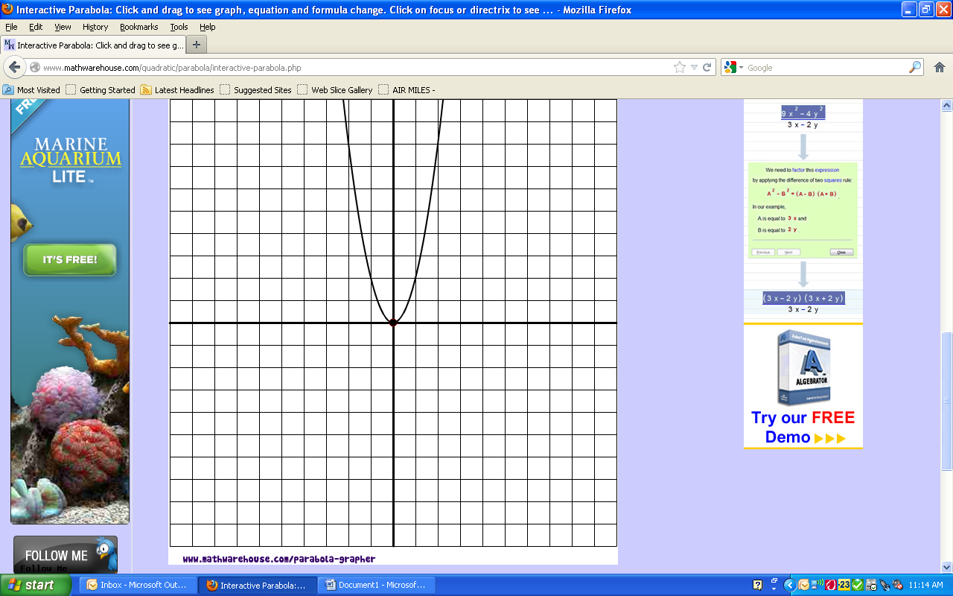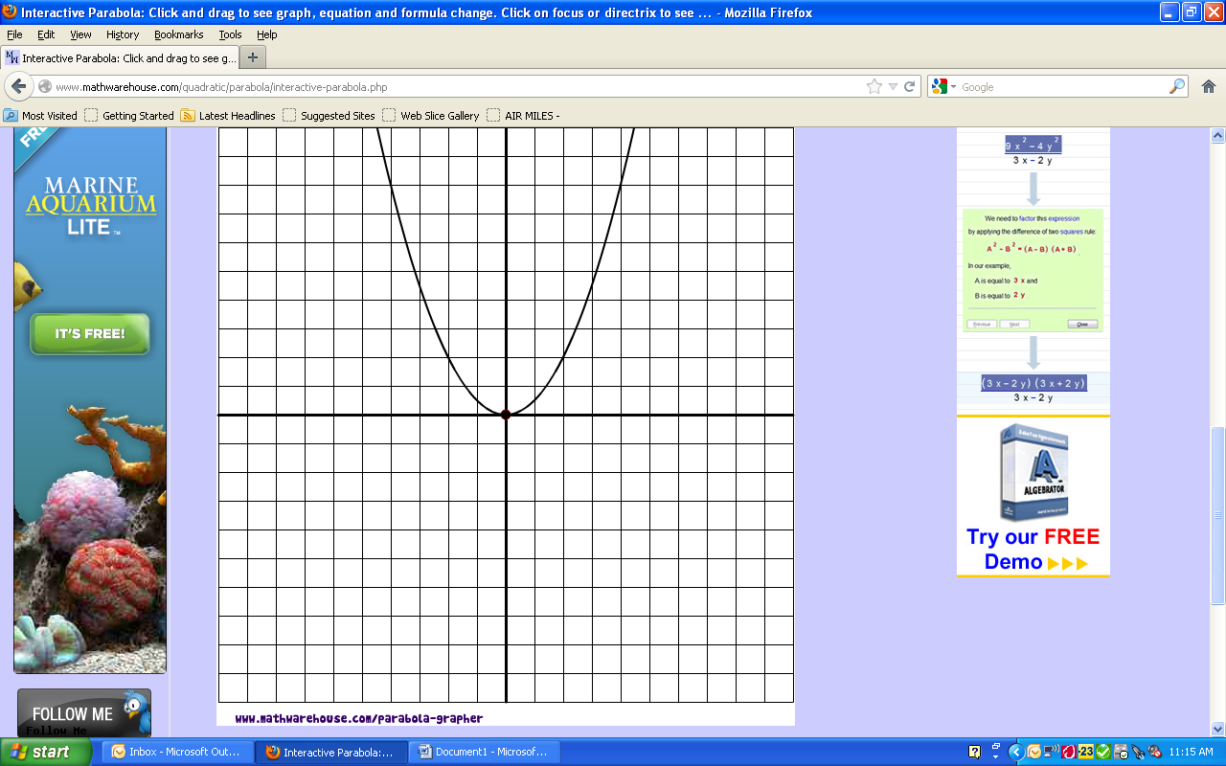

f(x) = f(x) = f(x) = ${\frac{1}{2}x}^{2}$

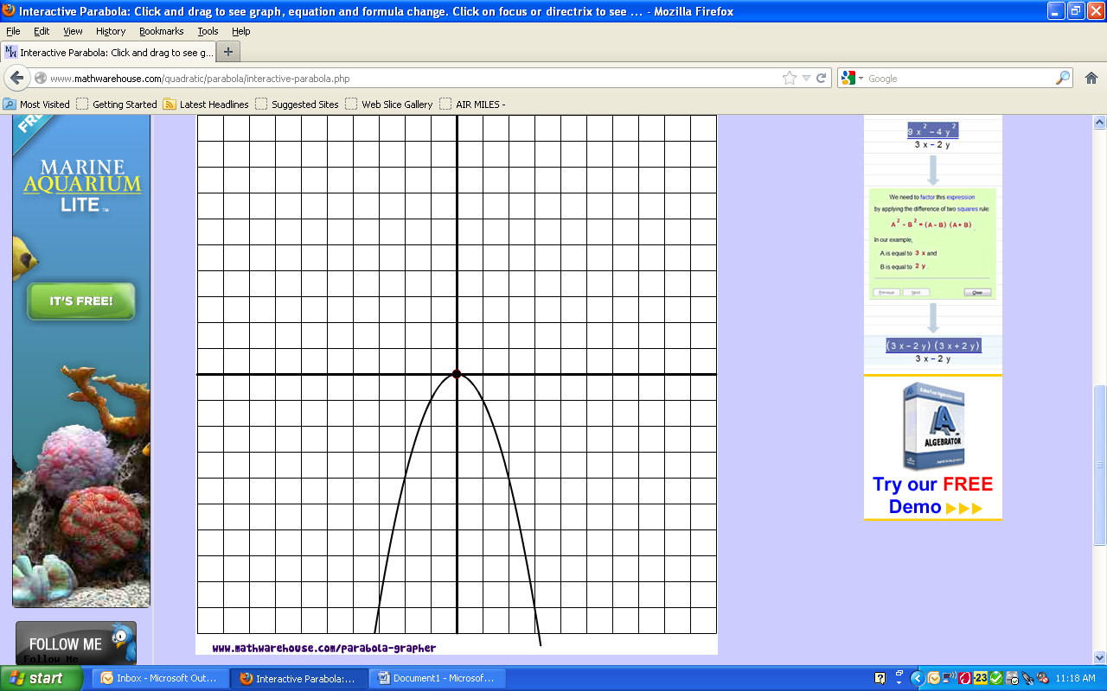 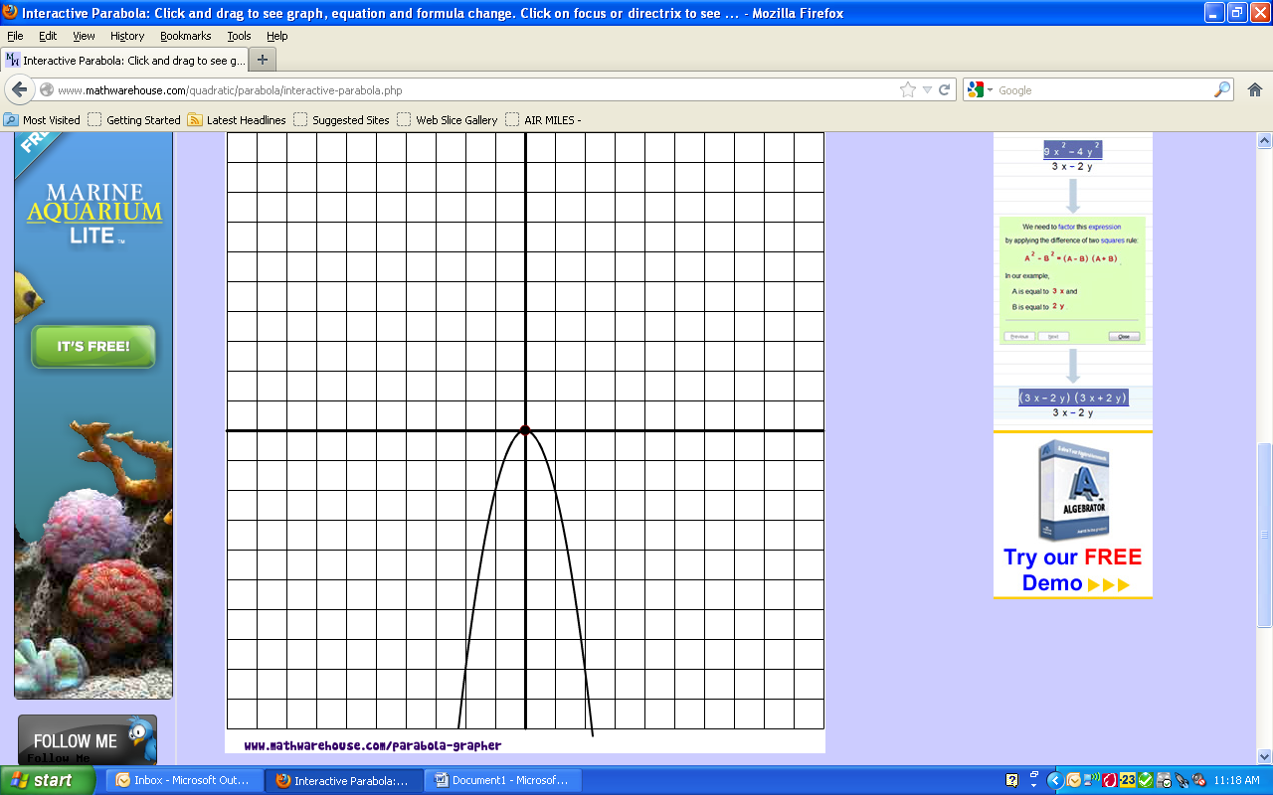 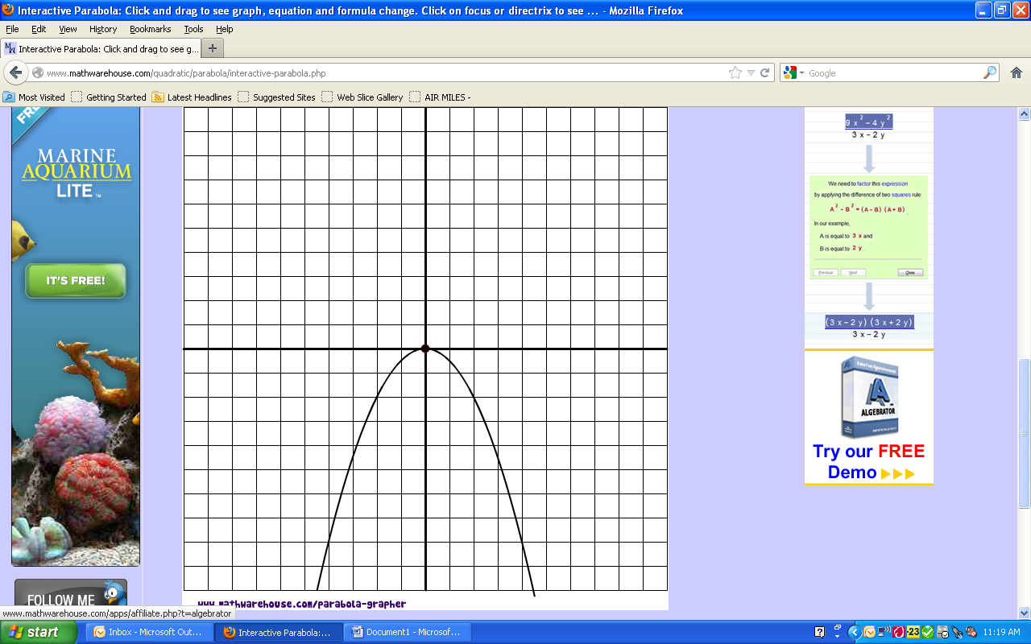

f(x) = - $x^{2}$ f(x)= - ${2x}^{2}$ f(x) = - ${\frac{1}{2}x}^{2}$

***How does the value of “a” affect the graph of f(x)= ax2* ?**

* if “*a*” is positive, __________________________________
* if “*a*” is negative, __________________________________
* , the graph is _________________
* , the graph is _________________
* , the graph is _________________

***B. Compare the graphs of f(x)= x2 and f(x)= x2 + q***

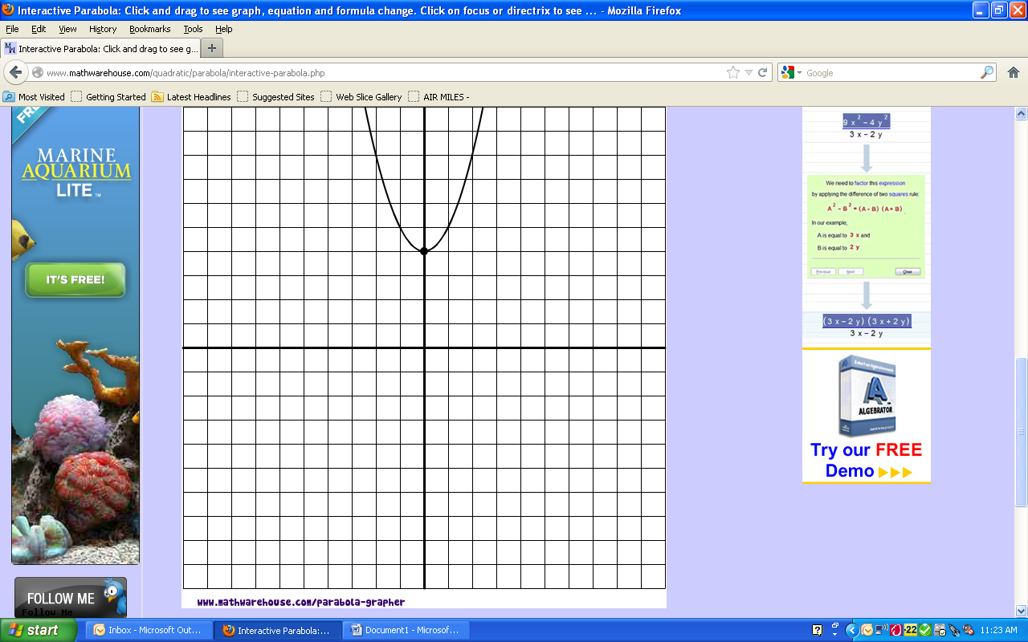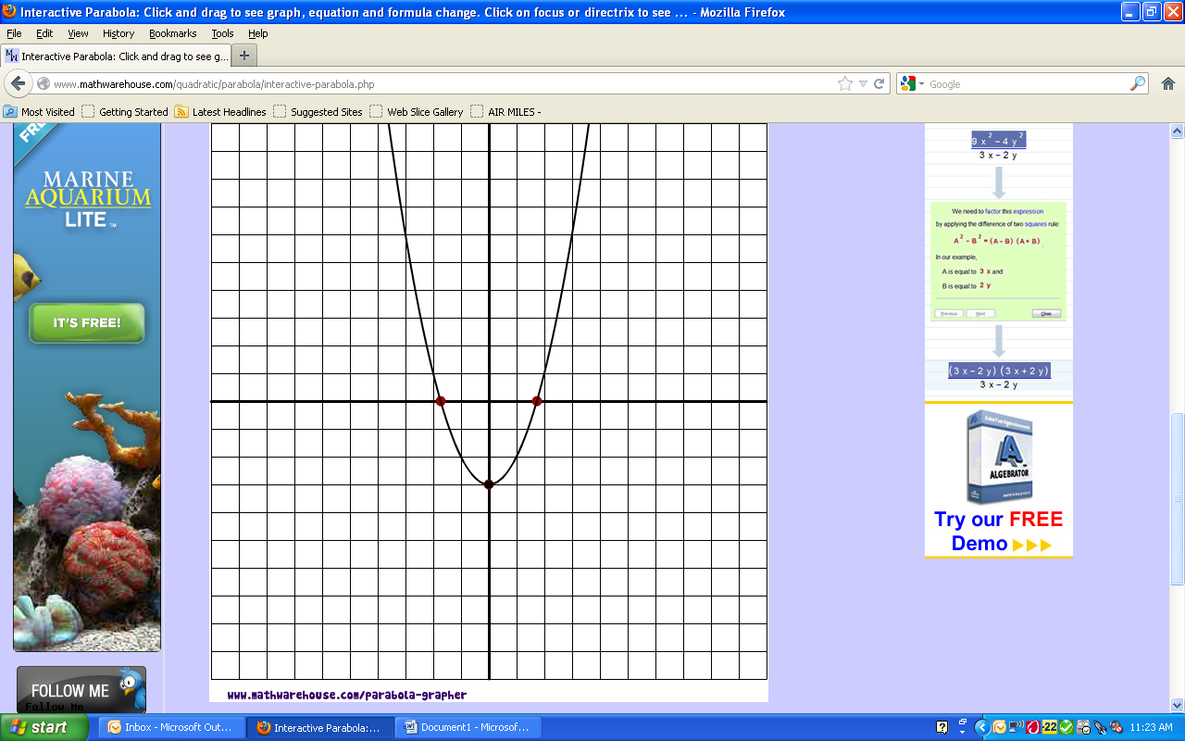

f(x) = f(x) = f(x) = $x^{2}-3$

***How does the value of “q” affect the graph of f(x)= x2 + q?***

* The value of “q” indicates a _____________ shift. If q > 0, graph moves ____________

If q < 0, graph moves ____________

***C. Compare the graphs of f(x)= x2 and f(x)= (x – p)2***

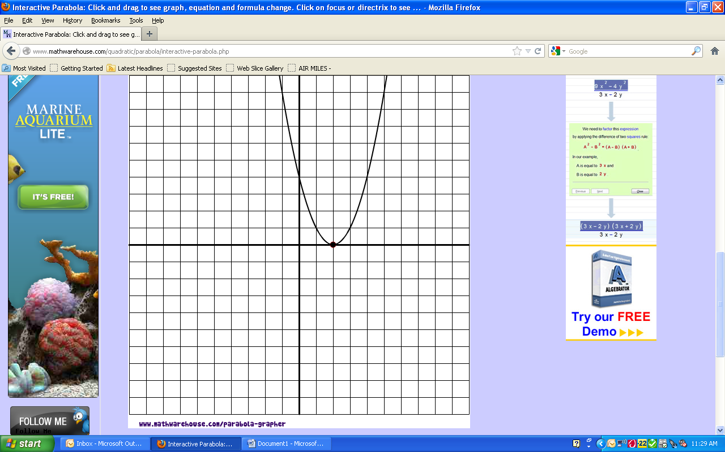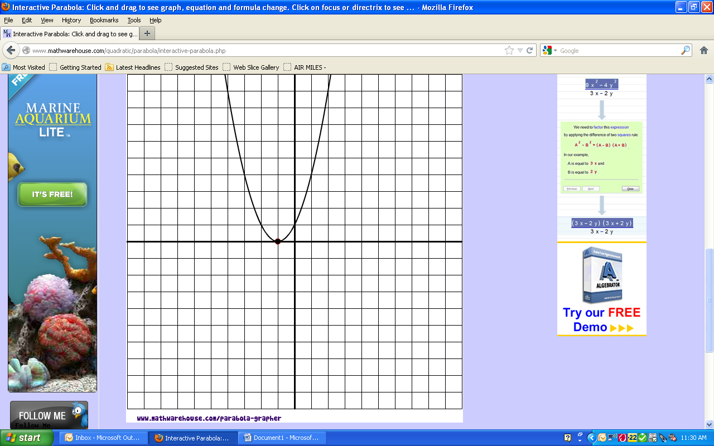

f(x) = f(x) = f(x) = (${x+1)}^{2}$

***How does the value of “p” affect the graph of f(x)= (x – p)2?***

The value of “p” indicates a _____________ shift. If p > 0, graph moves ____________

If p < 0, graph moves ____________

Summary:

* In VERTEX FORM  , the follow_ing is true:
  + The coordinates of the vertex are at (__ , ___ )
  + The equation of the axis of symmetry is at ___________
  + If the value of “a” is negative, the graph will open ________ and have a ____________ value at ___________
  + If the value of “a” is positive, the graph will open ________ and have a ____________ value at ___________
  + The parabola will be of normal width if _____________
  + The parabola will be narrower if _______________
  + The parabola will be wider if __________________
  + The value of “p” moves the parabola ________________________
  + The value of “q” moves the parabola ________________________
  + The domain of a parabola (with arrowheads) will be ____________________ in set notation

and __________________ in interval notation

* + The range of a parabola (with arrowheads) will be ______________________ in set notation

and _________________ in interval notation

EX #3: Determine the number of x intercepts of each quadratic function by visualizing the graph.

|  |  |  |  |  |
| --- | --- | --- | --- | --- |
|  | VERTEX | DIRECTION OF OPENING | VISUALIZE & SKETCH THE GRAPH | NUMBER OF X INTERCEPTS |
|  |  |  |  |  |
|  |  |  |  |  |
|  |  |  |  |  |

EX #4: **Complete the following chart and sketch the last two functions using a table of values and key points**

**Note: Domain and Range you can use interval or set notation. (If you did not take Enriched Foundations 10 see video on my website to teach you)**

|  |  |  |  |  |  |
| --- | --- | --- | --- | --- | --- |
|  |  |  |  |  |  |
| **Value of a** |  |  |  |  |  |
| **Value of p** |  |  |  |  |  |
| **Value of q** |  |  |  |  |  |
| **Direction of opening** |  |  |  |  |  |
| **Width( Normal , Wide Narrow)** |  |  |  |  |  |
| **Vertex** |  |  |  |  |  |
| **Max/Min** |  |  |  |  |  |
| **Axis of Symmetry** |  |  |  |  |  |
| **Domain** |  |  |  |  |  |
| **Range** |  |  |  |  |  |
| **# of x-intercepts** |  |  |  |  |  |
| **Y intercept** |  |  |  |  |  |
| **Reflection of the y intercept** |  |  |  |  |  |



**3.1 Assignment #1: Chart assignment and Pg 157 #1ad, 2bc and Extension question #19**

**3.1 Day 3 Quadratic Functions in Vertex Form**

Concept#2: To graph quadratic functions in the form f(x)=a(x – p)2 + q using transformations.

EX #1: Sketch the graph of **y = 3(x + 2)2 – 4** using transformations.

* **STEP 1**: Describe what the numerical change to “a” is compared to its parent PARENT FUNCTION (base function, original function) **y = x2**.
* How will this change alter the graph of the PARENT FUNCTION) **y = x2**?
* Will this change affect the x or the y value of the ordered pairs of the parent function?

Let’s compare the table of ordered pairs between the parent function and the Step 1 Transformed table (which is the

parent function with just the value of “a” changed – we won’t worry about the values of “p” and “q” yet)

Describe what changes & how:

|  |  |
| --- | --- |
| PARENT FUNCTION  y = x2 | |
| x | y |
|  |  |
|  |  |
|  |  |
|  |  |
|  |  |

|  |  |
| --- | --- |
| STEP 1 of TRANSFORMED FUNCTION  y =___x2 | |
| x | y |
|  |  |
|  |  |
|  |  |
|  |  |
|  |  |

* **STEP 2:** Describe how “p” and q” have changed compared to the parent function y = x2
* How will this change alter the graph of the PARENT FUNCTION y = x2?
* How will p and q affect where the parent function moves to?

* Describe how x moves and how y moves.
* Fill in the Step 2 table by moving the x and y values by the appropriate amounts
* Sketch the graph using the Step 2 table.

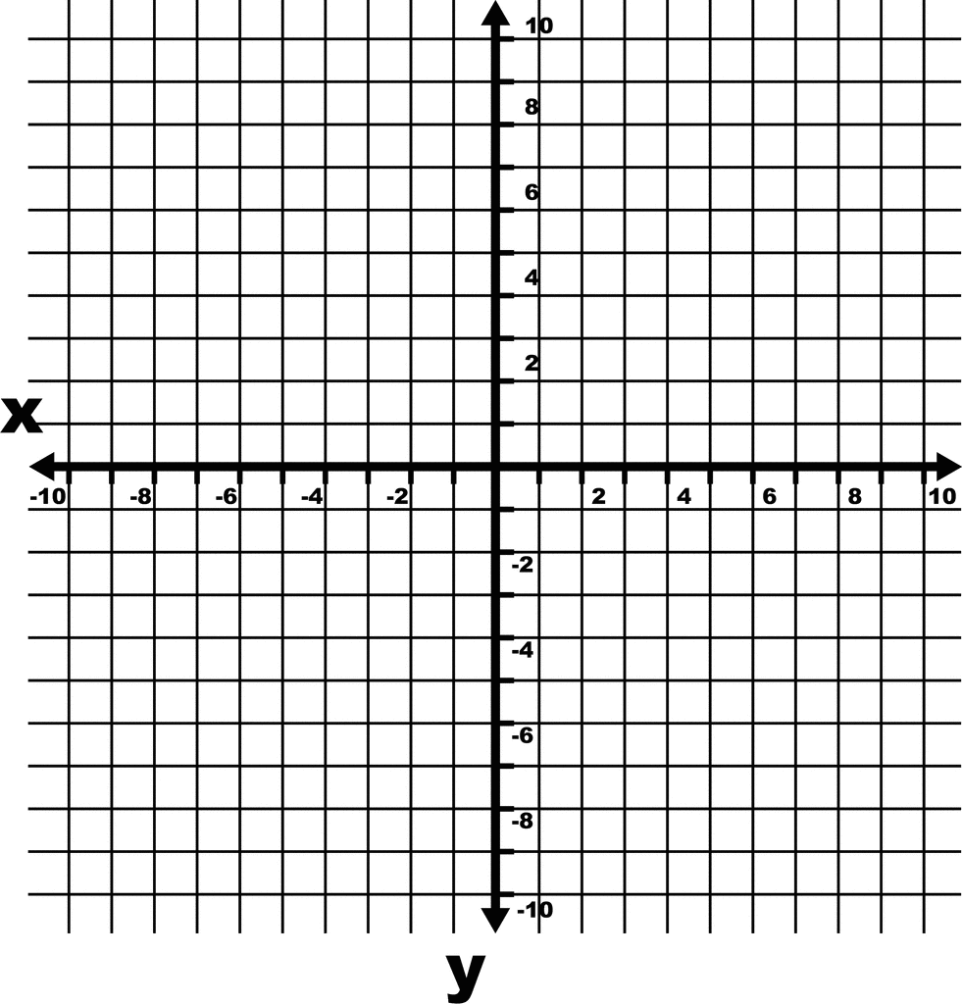

Describe what changes & how:

|  |  |
| --- | --- |
| STEP 2 of TRANSFORMED FUNCTION  y =___(x____)2_____ | |
| x | y |
|  |  |
|  |  |
|  |  |
|  |  |
|  |  |

EX #2: Sketch the graph of  using transformations.

Describe what changes & how:

|  |  |
| --- | --- |
| PARENT FUNCTION  y = x2 | |
| x | y |
|  |  |
|  |  |
|  |  |
|  |  |
|  |  |

|  |  |
| --- | --- |
| STEP 1 of TRANSFORMED FUNCTION  y =___x2 | |
| x | y |
|  |  |
|  |  |
|  |  |
|  |  |
|  |  |

|  |  |
| --- | --- |
| STEP 2 of TRANSFORMED FUNCTION  y =___(x____)2_____ | |
| x | y |
|  |  |
|  |  |
|  |  |
|  |  |
|  |  |

Describe what changes & how:



**3.1 Assignment #2**

**Pg 157 #3 & Extra Question 1 Below Pg 158 #10 ( No Graphing Calculator)**

1. Graph the following functions using transformations. Make sure to state transformations, the vertex and show the new tables of values. It is imperative that you use graph paper and a ruler!!
2.  d) 
3.  e) 
4.  f) 

**3.1 Day 4 – Quadratic Functions in Vertex Form**

Concept #3: To write quadratic functions in vertex form given a graph or situation and to solve situational questions.

EX #1: Determine the quadratic function in vertex form for the following graphs.

a) 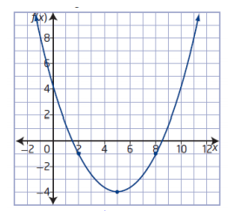 b) 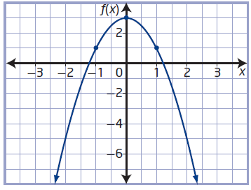

EX #2: Suppose a parabolic archway has a width of 280 cm and a height of 216 cm at its highest point above the floor.

a) Write a quadratic function in vertex form that models the shape of this archway. b) Determine the height of the archway at a point that is 50 cm from its outer edge.

c) Is there more than one answer for part “a”. Why?

EX #3: Determine a quadratic function with the following characteristics: a minimum of 12 at x = -4 and y-intercept of 60.

3.1Assignment #3: Pg158 #8abc, 9abd & at least 2 of the following:13, 16, 17, 18

(No Graphing Calculator) **Note: in some textbooks #17 may be incorrect in the back of the book.**

**3.2 Quadratics in Standard Form**

Concept #4 : To determine the coordinates of the vertex, the domain and range, the axis of symmetry, the x and y intercepts and the direction of opening of the graph of a function in standard form y = ax2 + bx + c

A quadratic in standard form is y = ax2 + bx + c or f(x) = ax2 + bx + c where a, b and c are real numbers and 

* *a* determines the width of the parabola and whether the parabola opens upwards or downwards (the same as it did for vertex form)
* *b* INFLUENES the position of the graph (vertex)
* *c*  determines the y intercept of the graph
* In Foundations 20, we found the x value of the vertex by calculating the x intercepts and finding the middle x value of those intercepts. We will now develop a formula that we can use
  +  the x-coordinate of the vertex can be calculated by using the formula
  + The y coordinate of the vertex can be found by substituting the above answer into the original function

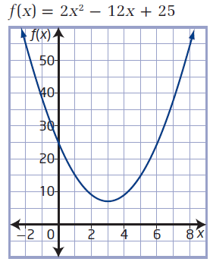

EX #1: Using the graph , determine the vertex, direction of opening, axis of symmetry, max/min value, domain, range and y intercept

EX #2: Without looking at a graph, determine the same information as in example 1 for the following:

a) y = x2 + 6x + 5 b) y = -x2 + 2x + 3

Vertex: Vertex:

Directions of opening: Direction of opening:

Equation of axis of symmetry: Equations of the axis of symmetry:

Min or max Value: Min or Max Value:

Domain: Domain:

Range: Range:

Y- int.: Y- Int.:

Concept #5: Solve situational problems involving Quadratics in standard form y = ax2 + bx + c

EX #3:

A diver jumps from a 3-m springboard with an initial vertical velocity of 6.8 m/s and hits the water after approx.. 1.74 secs. Her height, *h*, in metres, above the water *t* seconds after leaving the diving board can be modelled by the function *h*(*t*) = -4.9*t*2 + 6.8*t* + 3.

**a)** Graph the function by finding the vertex, x intercept(s), y intercept and it’s reflection.

**b)** What does the *y*-intercept represent?

**c)** What maximum height does the diver reach? When does she reach that height?

**d)** What domain and range are appropriate in this situation?

**e)** What is the height of the diver 0.6 s after leaving the board?

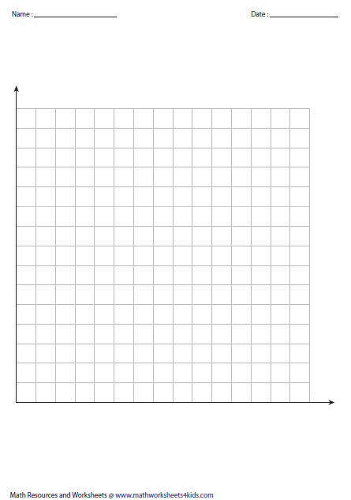

**3.2 Assignment Pg 174 #1,2,3,6,7a-d,11**

**(TEACHER NOTES)3.3 Changing from Standard Form to Vertex form (Completing the Square)**

Concept: To change the form of a quadratic function from Standard Form, y = ax² + bx + c, to Vertex Graphing Form, y = a(x – p)2 + q (note that it is sometimes called y = a(x – h)2 + k

EX #1: Rewrite the following quadratic function from vertex form to standard form

y = (x + 2)2 – 5

What form do you feel is more helpful in being able to quickly sketch the graph? Why?

**Continue the pattern**

1. 
2. 
3. 
4. **_____________­­­­­­­_____= _________________________=_____________**
5. **__________­­­­­________= _________________________=_____________**
6. **__________________= _________________________=_____________**

**12) __________________= _________________________=______________**



**3.3 Changing from Standard Form to Vertex form (Completing the Square)**

**Concept #6: To change the form of a quadratic function from Standard Form, y = ax² + bx + c, to Vertex Graphing Form, y = a(x – p)2 + q (note that it is sometimes called y = a(x – h)2 + k**

Quadratic functions are often written in ***standard******form***:. While it is easy to find the *y*-intercept when the function is given in this form, it is more difficult to graph the function.

We will use a procedure called ***completing the square*** to rewrite the function in vertex form, , so that we can more easily identify the characteristics and graph the function.

**Completing The Square**

Ex. 1/ Rewrite the function y = x2 + 6x – 4 to VERTEX form (From the form y = ax2 + bx + c to the form y = a(x – p)2 + q)

What is the vertex of this function?

STEPS FOR WRITING IN VERTEX FORM WHEN a = 1

1. Move the value of “c” to the left side of the function.
2. When the value of a = 1, calculate the value of  and add this value to both sides of the function.
3. Simplify the left side of the function and factor the right side of the function. Note that the function will now always factor into a perfect square of the form 
4. Move the constant on the left side to the right side.

Ex2. Rewrite the following in vertex form. What is the max/min of each parabola?

a) y = x2 + 8x – 5 b) y = x2 + 9x - 1

Ex3. Rewrite the following in Vertex form:

STEPS WRITING IN VERTEX FORM WHEN a 1

1. Move the value of “c” to the left side of the function.
2. Factor out the value of “a” on the right side (even if it doesn’t factor out evenly you must factor it out! To factor it out of “b” when it isn’t divisible by “a” you will turn the term into  ) **Leave a short space inside the brackets on the right end.**
3. Calculate the value of  and add this value to THE RIGHT SIDE side of the function only (add this value where you left the space inside the brackets)
4. Now calculate the value of  and add this value to the LEFT side the function.
5. Simplify the left side of the function and factor the right side of the function. Note that the function will now always factor into a perfect square of the form 
6. Move the constant on the left side to the right side.

a) y = 2x2 – 16x + 11

b) 

c)  d) y = -5x2 – 8x

* 1. **Assignment Pg 193 #5d, 7e, 8c** Complete 1 and 2 first on the NEXT PAGE

1. Rewrite the following functions in Vertex Form by Completing the Square.

1.  b)  c) 
2.  e)  f) 
3.  h)  i) 
4.  k) 
5. Find each of the following answers for each question in #1 above:

**i)** Vertex **ii)** Axis of Symmetry **iii**) Direction of Opening **iv)** Max/Min **v)**Y intercept **vi)**Domain **vii)** Range

**Answers to #1 and #2:**

1a) b)  c)  d) 

e)  f)  g)  h)  i)  j)  k) 

|  |  |  |  |  |  |  |
| --- | --- | --- | --- | --- | --- | --- |
| i)(2,-9) | ii)x=2 | iii)up | iv)min at y=-9 | v)(0,-5) | vi)domain | vii)Range [-9, |

2a)

|  |  |  |  |  |  |  |
| --- | --- | --- | --- | --- | --- | --- |
| i)(-3,-25) | ii) x=-3 | iii)up | iv)min at y=-25 | v) (0,-16) | vi) | vii) [-25, |

b)

|  |  |  |  |  |  |  |
| --- | --- | --- | --- | --- | --- | --- |
| i)(4,2) | ii)x=4 | iii)up | iv)min at y=2 | v) (0,18) | vi) | vii) [2, |

c)

|  |  |  |  |  |  |  |
| --- | --- | --- | --- | --- | --- | --- |
| i) (-5,-25) | ii)x=-5 | iii)up | iv) min at y=-25 | v)(0,0) | vi) | vii) [-25, |

d)

|  |  |  |  |  |  |  |
| --- | --- | --- | --- | --- | --- | --- |
| i) | ii) | iii)up | iv)min at y = | v)(0,0) | vi) | vii) [, |

e)

|  |  |  |  |  |  |  |
| --- | --- | --- | --- | --- | --- | --- |
| i) | ii)x = | iii)up | iv)min at y= | v) (0,-10) | vi) | vii) |

f)

|  |  |  |  |  |  |  |
| --- | --- | --- | --- | --- | --- | --- |
| i)(2,16) | ii) x=2 | iii) down | iv) max at y=16 | v)(0,12) | vi) | vii) |

g)

|  |  |  |  |  |  |  |
| --- | --- | --- | --- | --- | --- | --- |
| i)(-2, -27) | ii)x = -2 | iii)up | iv)min at y= -27 | v) (0,-15) | vi) | vii) |

h)

|  |  |  |  |  |  |  |
| --- | --- | --- | --- | --- | --- | --- |
| i) | ii) | iii)up | iv) min at y= | v) (0,-3) | vi) | vii) |

i)

|  |  |  |  |  |  |  |
| --- | --- | --- | --- | --- | --- | --- |
| i)(-3, -7) | ii) x = -3 | iii)up | iv)min at y=-7 | v)(0,-4) | vi) | vii) |

j)

|  |  |  |  |  |  |  |
| --- | --- | --- | --- | --- | --- | --- |
| i) | ii)x=-1 | iii)up | iv) min at  y =-17/2 | v) (0,-8) | vi) | vii) |

k)

**3.3 (Day 2) Max and Min Word Problems with Quadratic Functions**

**Concept #7: To solve situational questions involving maximums and minimums of a quadratic functions.**

Ex.#1: Two numbers have a sum of 29 and a product that is a maximum. Determine the two numbers and

the maximum product.

Ex#2: A sporting goods store sells reusable sports water bottles for $8. At this price their weekly sales are approximately 100 items. Research says that for every $2 increase in price, the manager can expect the store to sell five fewer water bottles.

Determine the maximum revenue the manager can expect based on these estimates. What selling price will give that maximum revenue?

EX #3: At a children’s music festival, the organizers are roping off a rectangular area for stroller parking. There is 160 m of rope available to create the perimeter.

**a)** Write a quadratic function in standard form to represent the possible area for the stroller parking.

**b)** What are the coordinates of the vertex? What does the vertex represent in this situation?

**c)** Sketch the graph for the function you determined in part a).

**d)** Determine the domain and range for this situation.

**e)** Identify any assumptions you made.

3.3 Assignment #2 Complete the 5 questions below then Pg 177 #15 and Pg 195 #18. Challenge yourself with Pg 196 #25 and #28

1. Solve the following problems algebraically using the vertex formula and completing the square.

a) What is the maximum product that two numbers can have if their sum is 100? What are the two numbers?

b) One number is 10 larger than another. What is the smallest possible value for the sum of their squares?

What are the two numbers?

1. A farmer wishes to fence in a rectangular pen using his barn as one of the sides of the rectangle. If the farmer has 40 m of fencing, what is the largest area that can be enclosed? What are the dimensions of the rectangle?
2. The managers of a business are examining costs. It is more cost-effective for them to produce more items. However, if too many items are produced, their costs will rise because of factors such as storage and overstock. Suppose that they model the cost, *C*, of producing *n* thousand items with the function: . Determine the number of items that will minimize their costs.
3. A gymnast is jumping on a trampoline. His height, *h*, in metres, above the floor on each jump is roughly approximated by the function where *t* represents the time, in seconds, since he left the trampoline. Determine his maximum height on each jump.
4. Sandra is practicing at an archery club. The height, *h*, in feet, of the arrow on one of her shots can be modelled as a function of time, *t* in seconds, since it was fired using the function. What is the maximum height of the arrow, in feet, and when does it reach that height?

**Answers:**

1. a) Max product is 2500 when the numbers are 50 and 50 b) Min sum is 50 when the numbers are -5 and 5
2. Max area is 200 m2 when the rectangle is 10m by 20m.
3. 12 000 items
4. 9m
5. Max height is 5.56ft after 0.31 seconds being shot